Plaza Sale Wesite Update
*

- Home Page (web)
  - Banner animation some times disapare.
  - Banner Explore Products link trigger at the right side of the bottom.
- Home Page (Mobile)
  - Lacking on mobile device
  - Text Visibility issue in “Explore Category section”.
  - Check Font size.
- Product page
  - WEB Version
    - Make Breadcom Capitalize
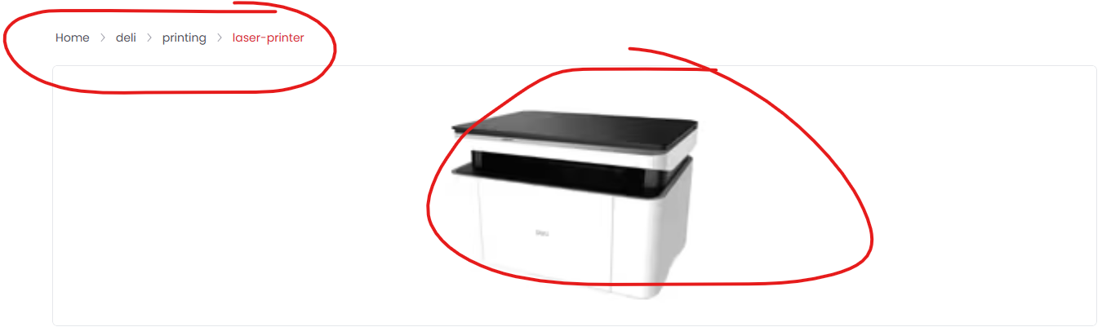
    - First image looks Blur (Send me the image ratio)
    - Check Font size and alignment .
    - Make inquiry smaller, correct spelling once.
    - Make Specification table Responsive.
    - Bold fonts looks little blur.
    - Product detail page header should be like brand page. With brand logo and plaza logo.
  - Mobile Version
    - The product image doesn’t look good; it’s taking up too much space and needs to be adjusted.
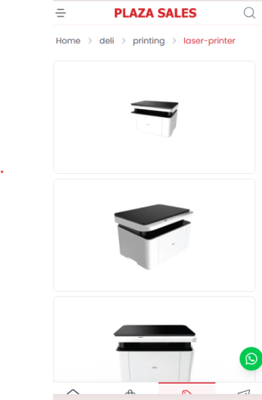
    - Make Inquiry button 30% smaller and align with product name.
    - Product specification table should be responsive.
    - Move the product model number closer to the product name.
- Page Title alignment need to be same. (web and mobile)
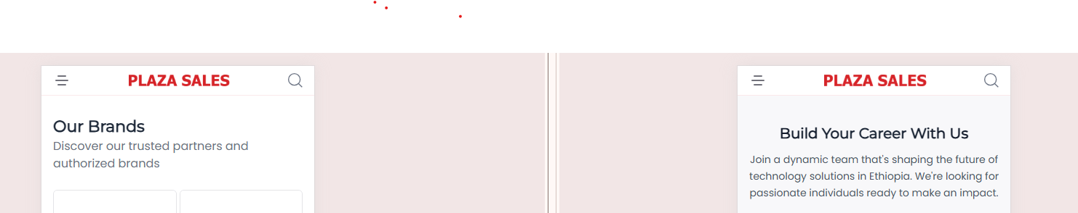
- Career page
  - Web Version
    - Change $ icon to Nrs.
    - Need to add time and date. (Apply before)
    - Edit page Content Disappear While Editing.
    - Check our format
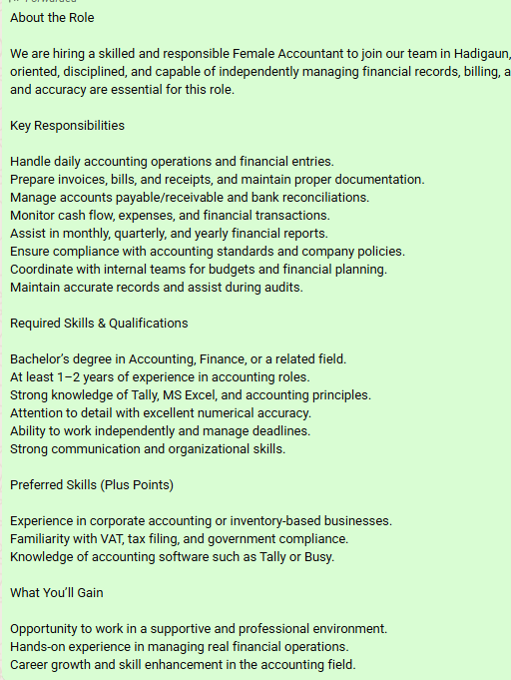

    - Apply For page form fields are too big need to fit in one page.
    - Need to add Nrs, and time in positon detail section.
- Contact Page. Need to reformat not looking good.
- About us page
  - Web
    - Check text alignment all page have left alignment.
    - Board Of Director make 3 column.
    - Check the font size.
    - Remove unnecessary white space from the page.
    - Need to change “Your Partner” Section design.
    - Logo icons are not showing

  - Mobile
    - Every Section Font size is different. Need constant size.
    - Remove unnecessary White space.
    - Can you make 2 column version for BOD.
- Product Category page (https://plazasales.webxnepal.com/categories)
  - Can you make Brand wise category section.
  - Product category text visibility issue in mobile device.

